**Innledende teknisk research**

**Aktuell hardware**

CPU

* Raspberry pi 4

CPU/GPU

* Nvidia Jetson Nano

ASIC

* Coral Edge TPU

Flight controller

* NAVIO2
* Pixracer
* F405

**Aktuell software**

* ROS2
* OpenCV
* Tensorflow

**Skisser**

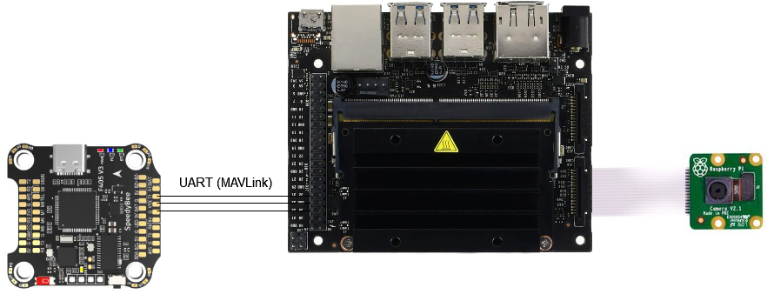

Figure : Jetson nano, rpi camera, flight controller

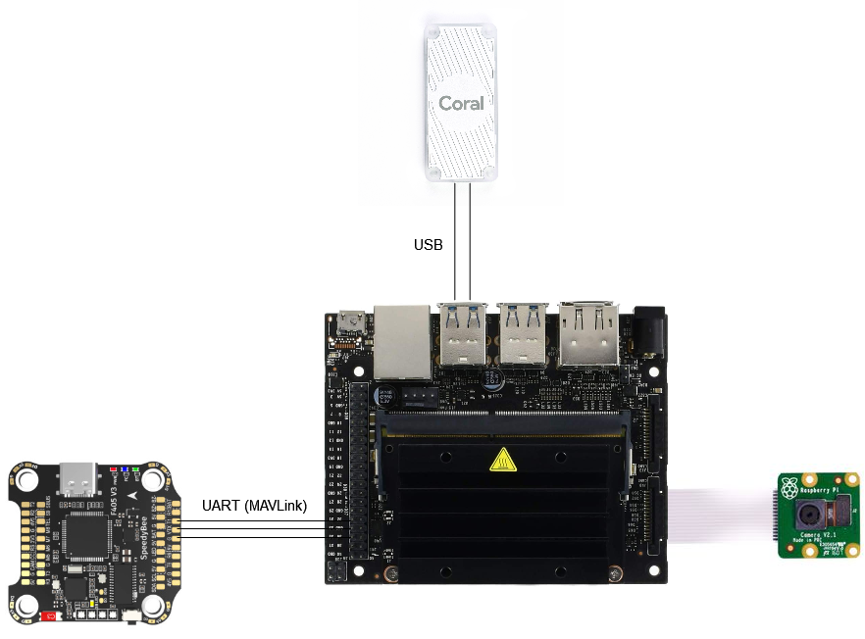

Figure : Jetson Nano, rpi camera, Edge TPU, flight controller

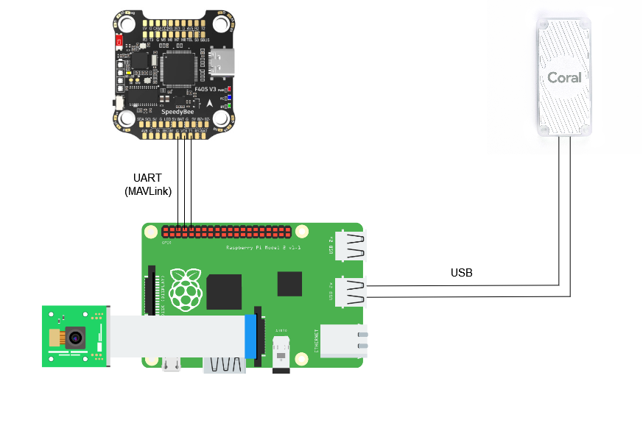

Figure : Raspberry Pi 4, rpi camera, flight controller

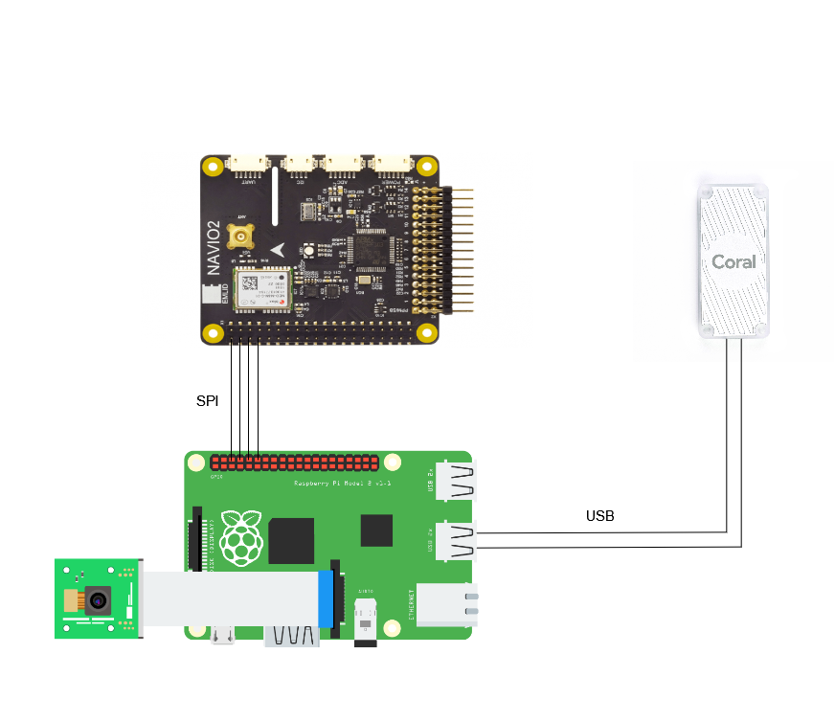

Figure : Raspberry Pi 4, rpi camera, NAVIO2, Edge TPU